How To Run RacketReady Application

**You can skip the first 2 steps if Android Studio is already installed on your desktop/laptop**

1. Before everything please have Android Studio application on your desktop/laptop. Any version of android studio is fine, but we used Hedgehog version for this application.

Direct yourself to the Hedgehog archive from here: <https://developer.android.com/studio/archive>



* A version of Android Studio that is up-to-date, or a newer version from Hedgehog is fine to.

1. Download the appropriate version (that is suitable to your operating device), unzip the file a run the installation. From there choose the appropriate installation settings best suited for you, the application should launch after installation.

A more in-depth installation guide can be founded here: <https://developer.android.com/studio/install>

1. Download our application from either GitHub or Blackboard, unzip the file once completed. From there you can open the folder from Android Studio by going to

File -> Open -> select our file, open RacketReady_MatchMatchHistory (will have an android icon), do not open the file further.

This is founded on the top-middle assuming you are within the home page.

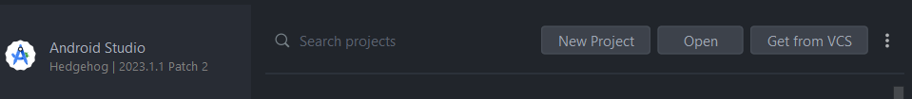

1. Once our file is opened, you are nearly ready to run RacketReady! There will be a wait time after opening our file to sync gradle/load our files.
2. Once everything is loaded, you can view all the codes/classes/diagrams and other files as well.
3. Navigate to Device Manager on the Right Side, and create a Device, choose any device (we used the Pixel 6) and take all the default settings.
4. After creating a device, you can run our app! If needed please see down below how to have prepopulated users to save time on registration.

**How to use Prepopulated Tables**

* This is a feature that allowed us to use prepopulated users on launch to avoid the time registering multiple accounts.

1. Within the login page, there will be commented code called db.prepopulatedTables, before running uncomment the code, run the app, and close the app and comment the code once again. This is to avoid populating the same users again after launch

* Underneath the code is where you’ll find default emails/passwords to use (all these accounts have matching locations, match level, and match type). You can use it as quick reference.